AUTOMATIC NEAR SURFACE LAYER ESTIMATION FROM SNOW RADAR IMAGERY

Jerome E. Mitchell¹, David J. Crandall¹, Geoffrey C. Fox¹, and John D. Paden²
¹School of Computing and Informatics, Indiana University – Bloomington, Bloomington, IN 47403 USA
²Center for Remote Sensing of Ice Sheets, University of Kansas, Lawrence, KS 66045 USA

Abstract
The long-term glaciological processes and past ice sheet structure are preserved in the near surface layer signatures of the polar ice sheets. Identifying and tracing near surface layers in snow radar images can be used to produce high-resolution accumulation maps. Scientists have manually traced layers in large data volumes, but it requires time-consuming, dense hand-selection and interpolation between sections.

We have developed an approach for automatically estimating near surface layers in snow radar echograms. Our solution utilizes an active contour model (called snakes) to find high-intensity edges likely to correspond to layer boundaries, while simultaneously imposing constraints on smoothness of layer depth and parallelism among layers.

Index Terms — Radar Image Processing, Near Surface Layers

- Introduction

The IPCC Fourth Assessment [10] reports considerable uncertainty associated with projected sea level change over the coming decades and century. Understanding the ice flow dynamics in Greenland and Antarctica poses a significant climate problem; even a modest change in ice sheet volume could strongly affect future sea level and freshwater flux to the oceans. This uncertainty could be substantially reduced by more and better observations of the polar ice sheets’ internal structure.

The Center for Remote Sensing of Ice Sheets (CReSIS) has developed a snow radar for NASA’s Operation Ice Bridge Ice program in order to image near-surface layers for producing high-resolution accumulation maps. Identifying near surface internal layers in radar imagery is important for the study of ice sheets and how they may contribute to global climate change, but it requires significant resources to complete a single radar data file consisting of thousands of measurements. Given the volume of radar data acquired in the past and its growth each year, automating this task is necessary for providing results to the scientific community in a timely manner. In this paper, we focus on automatically estimating near surface layers using snow radar data acquired in Antarctica.

- Related literature
Developing automatic techniques for near surface layers acquired in either Greenland or Antarctica has been insufficiently addressed. Most related works focused on echograms collected by orbital sounders operated on Mars. For example, [1] and [2] present two techniques for automatic detection of shallow ice features in icy regions. A method for detecting basal returns in echograms of the Martian subsurface is presented in [3]. Approaches to polar radar imagery have been addressed in [4], [5], and [6]. The authors in their respective works identified surface and bedrock layers. However, a more relevant method, [7] developed a signal processing algorithm for tracing near surface layers in Greenland. Therefore, the development of automatic techniques for identifying near surface layers is an imperative requirement, which has to be promptly applied in order to create reliable tools for a large quantity of echograms acquired in the Polar Regions.

3. methodology

As shown in Figure 1 and is typical for our experimental images, the surface reflection is very strong and near surface layer intensity generally decreases as depth increases. Also, near surface layers are parallel, but may have modest changes in slope, to one another and to the ice surface. Using observations about how domain experts detect layer boundaries can aid in the development of an automated algorithm to mimic these behaviors.

Our automatic algorithm uses an active contours method, called snakes, in addition to edge detection and curve point labeling for estimating near surface internal layers; each can be explained in detailed in subsections 5.1, 5.2, and 5.3, respectively. Figure 1 will be used for demonstrating the proposed approach.
Fig 1: Original Snow Radar Image

5.1. Edge Detection

Canny edge detection [11] uses linear filtering with a Gaussian kernel to smooth noise and to compute the edge strength and direction for each pixel in the image. Candidate edge pixels are identified through non-maximal suppression. In this process, the edge strength of each candidate edge pixel is set to zero if its edge strength is not larger than the edge strength of the two adjacent pixels in the gradient direction. Two edge strength thresholds on the edge magnitude is applied using hysteresis. All candidate edge pixels below the lower threshold are labeled as non-edges while all pixels above the low threshold, which can be connected to any pixel above the high threshold are labeled as edge pixels.

We used a canny edge detector (shown in Fig 2) because of its performance in detecting strong intensity contrasts for our near surface dataset. Since the ice surface is symmetrical to subsequent layers, it provides a good starting template. In detecting the initial ice curve, three specified were parameters: a sigma of 2 for the standard deviation of the Gaussian filter and a low and high thresholds of 0.7 and 1.8, respectively.

Fig 2: Canny Edge Detected Ice Surface

5.2. Curve Point Classification
In Steger [8] approach, curvilinear structures in a 2D image are modeled as curves, s(t) and represent a 1D line profile (shown in Fig 4) with a direction perpendicular to s’(t). The 1D line profile of a curve point vanishes in the first derivative and is the largest absolute value in the second derivative. Thus, at a curve point, the first derivative in the direction to s’(t) should vanish and the second directional should be the maximum absolute value. A pixel in an image is classified as a curve point if the first derivative along the direction perpendicular to s’(t) vanishes within a unit square centered around the pixel. Computing the perpendicular direction, s’(t), for a pixel can be accomplished by finding the eigenvector, which corresponds to the largest absolute eigenvalue of the Hessian matrix of the pixel. The Hessian matrix consists of the partial derivatives, I_{xx}, I_{xy}, I_{yx}, and I_{yy}, of the image after convolving with a Gaussian kernel. This detection is performed for each pixel for finding all pixels lying on a curve.

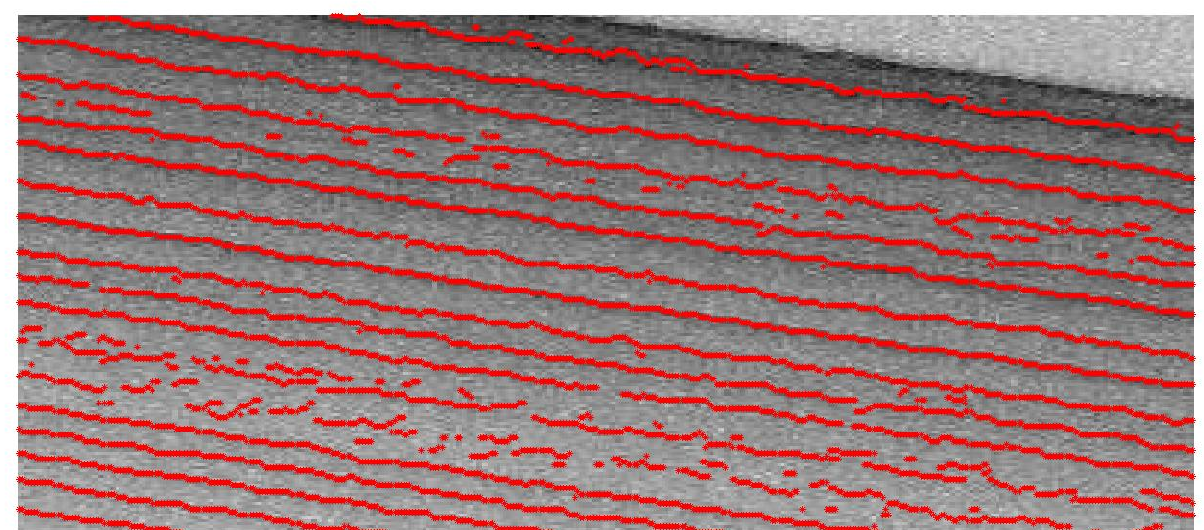
Fig 3: Curve Point Labeling

In Fig. 4, two points, P1 and P2 and their directional vectors are shown as an example. The directional vector at a pixel point represents the greatest curvature direction, which is determined by finding the eigenvector corresponding to the greatest eigenvalue of the Hessian matrix at each pixel. The point P1 is declared as curve point because the first directional derivative vanishes within the current pixel. However, the point P2 is not declared as a curve point because the first directional derivative does not vanish within the pixel boundary of P2.

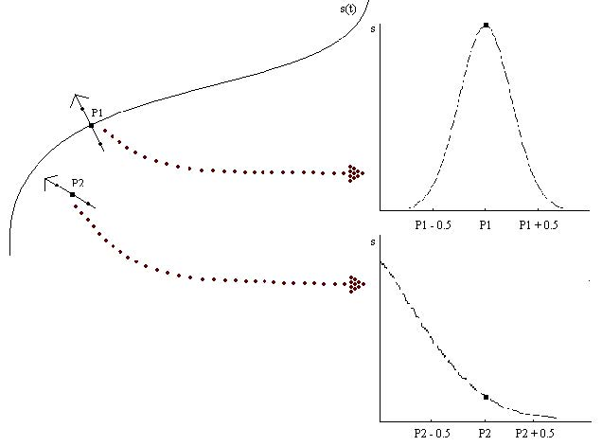
Fig 4

For our approach (shown in Fig. 3), Steger’s curves points suggest the initial curve position for estimating near surface layers (shown from the blue asterisks in Fig. 5). For each layer, the initial layer is shifted in the y direction from the previous curve point of the detected layer to the next maximum curve point for a layer; this process is repeated until x number of specified layers are detected (shown in green in Fig 5).

Although a curve point was detected (the blue asterisk outlier), a layer was unable to be detected because of the noisy, weak layers towards the bottom of the ice sheet.

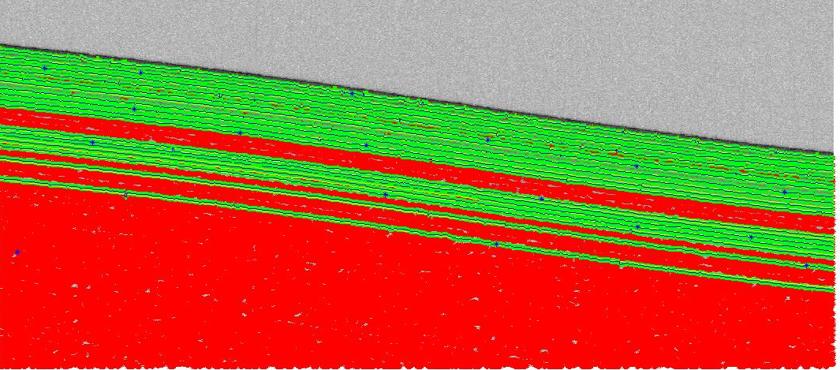
Fig. 5

5.3. Active Contours (Snakes)
In active contours [9], a snake is defined as an energy minimization spline, which deforms to minimize the energy. The energy function converges toward the boundary of a target by the following:

E_{snake} = $\int_{0}^{1}{(α* E_{elastic\left(v\left(s\right)\right)}}$+$β$ * $E_{bending\left(v\left(s\right)\right)}$ + $γ$ * $E_{image\left(v\left(s\right)\right)}$) ds

The first two energy terms in the energy equation are the internal energy, which represent the tension and rigidity. The third term is called external energy, and it attracts the snake to the near surface layer.

The internal energy can be divided in to two energy components: elasticity and bending forces. The internal energy is the sum of these forces and is expressed as

E_{internal} $=\frac{\left[α\left(s\right)*\left|\frac{dv\left(s\right)}{ds}\right|+ β\left(s\right)* \left|{\left(\frac{{dv\left(s\right)}^{2}}{{ds}^{2}}\right)}^{2}\right|\right]}{2}$

The first and second derivatives of the contour represent these energy terms and are called elastic forces and bending forces, respectively. The elastic force controls the tension of the snake while the bending force controls the rigidity of the snake.

The parameters $α$ (s) and $β$(s) as coefficients of each term represents weighting functions.

The external energy is derived from the image. This image force attracts the snake to move toward the contour. The energy term is defined as:

E_{external}(s) = -$γ\left(s\right)*{| ∇*(G_{σ}I\left(s\right))|}^{2}$

$∇$ represents the gradient operation and I(s) is the intensity of the image at s. $G_{σ}$ is a 2D Gaussian function with standard deviation $σ$. The weighting function $γ\left(s\right)$ controls the image force.

In our methodology, the initial contour must be close to the original layer in order for the snake to move toward noises or other undesired edges in the image. Selecting $α,$ $β,$ and $γ$ values were chosen arbitrarily and were optimized through trial and error depending on the best fit for a particular layer. A layer is fit when the maximum number of iterations has reached its threshold.

6. Conclusion
We have developed an automated approach to estimating near surface layers in snow radar imagery. Our solution utilizes an active contour model in addition to edge detection and Steger’s curve classification ultimately unburden domain experts from selecting incorrect ice interfaces and from the task of dense hand selection. By providing tools to the polar science community, high resolution accumulation maps can be readily processed to determine the contribution of global climate change on sea level rise. Figures 6-8 show our approach evaluated on snow radar images.

7. acknowledgements
This research was supported by the National Science Foundation Grants CNS-0723054 and OCI-0636361 Any opinions, findings, and conclusions or recommendations expressed in this work are those of the author (s) and do not necessarily reflect the views of the National Science Foundation.

8. References

[1] Greg J Freeman, Alan C Bovik, and John W Holt, “Automated detection of near surface martian ice layers in orbital radar data,” in Image Analysis & Interpretation (SSIAI), 2010 IEEE Southwest Symposium on. IEEE, 2010, pp. 117–120.

[2] Adamo Ferro and Lorenzo Bruzzone, “Automatic extraction and analysis of ice layering in radar sounder data,” 2013.

[3] Adamo Ferro and Lorenzo Bruzzone, “Analysis of radar sounder signals for the automatic detection and characterization of subsurface features,” 2012.

[4] David J Crandall, Geoffrey C Fox, and John D Paden, “Layer-finding in radar echograms using probabilistic graphical models,” in Pattern Recognition (ICPR), 2012 21st International Conference on. IEEE, 2012, pp. 1530–1533.

[5] MA Reid, Christopher M Gifford, Michael Jefferson,
Eric L Akers, Gladys Finyom, and Arvin Agah, “Automated polar ice thickness estimation from radar imagery,” in Geoscience and Remote Sensing Symposium (IGARSS), 2010 IEEE International. IEEE, 2010, pp. 2406–2409.

[6] Ana-Maria Ilisei, Adamo Ferro, and Lorenzo Bruzzone, “A technique for the automatic estimation of ice thickness and bedrock properties from radar sounder data acquired at antarctica,” in Geoscience and Remote Sensing Symposium (IGARSS), 2012 IEEE International. IEEE, 2012, pp. 4457–4460.

[7] M Fahnestock, W Abdalati, S Luo, and S Gogineni, “Internal layer tracing and age-depth-accumulation relationships for the northern greenland ice sheet,” Journal of geophysical research, vol. 106, no. D24, pp. 33789–33, 2001.

[8] Carsten Steger: “An Unbiased Detector of Curvilinear Structures”; in IEEE Transactions on PAMI, 20(2), Feb. 1998, 113-125

[9] M. Kass, A. Witkin, and D. Terzopoulos. Snakes: Active
contour models. IJCV, 1(4): 321–331, 1988.

[10] The Physical Science Basis. Contribution of Working Group I to the Fourth Assessment Report of the Intergovernmental Panel on Climate Change [Solomon, S., D. Qin, M. Manning, Z. Chen, M. Marquis, K.B. Averyt, M.Tignor and H.L. Miller (eds.)], Tech. Rep. 4, Intergovernmental Panel on Climate Change, Cambridge University Press, Cambridge, United Kingdom and New York, USA.

[11] Canny, JF, Finding Edges and Lines in Images, MIT technical report AI-TR-720,1983.

Fig 6

Fig 7

Fig 8

